STUDY REPORT ON RESULT ANALYSIS

HOUSE PRICE PREDICTION:
import pandas as pd
from sklearn.model_selection import train_test_split
from sklearn.linear_model import LinearRegression
from sklearn.metrics import r2_score

data = pd.read_csv("house_price.csv")
print(data.head())

X = data.drop("Price", axis=1)
y = data["Price"]

X_train, X_test, y_train, y_test = train_test_split(
X, y, test_size=0.2, random_state=42
)

model = LinearRegression()
model.fit(X_train, y_train)
y_pred = model.predict(X_test)

print("Predicted House Prices:")
print(y_pred)

score = r2_score(y_test, y_pred)
print("\nR² Score (Accuracy):", score)
Using the above Code I have done the prediction. The algorithm used was linear regression for the prediction.
Initially I have 20rows, but for prediction I have used the first 5 rows of the dataset.
STUDENT PERFORMANCE PREDICTION:
import pandas as pd
from sklearn.model_selection import train_test_split
from sklearn.linear_model import LinearRegression
from sklearn.metrics import r2_score

data = pd.read_csv("student_performance.csv")
print(data.head())

X = data[["Study_Hours", "Attendance", "Internal_Marks", "Assignment_Score"]]
y = data["Final_Marks"]

X_train, X_test, y_train, y_test = train_test_split(
X, y, test_size=0.2, random_state=42
)

model = LinearRegression()
model.fit(X_train, y_train)
y_pred = model.predict(X_test)

print("Predicted Final Marks:")
print(y_pred)

score = r2_score(y_test, y_pred)
print("\nR² Score (Accuracy):", score)

Using the above Code I have done the prediction. The algorithm used was multiple linear regression for the prediction.
Initially I have 20rows, but for prediction I have used the first 5 rows of the dataset.

OUTPUT:

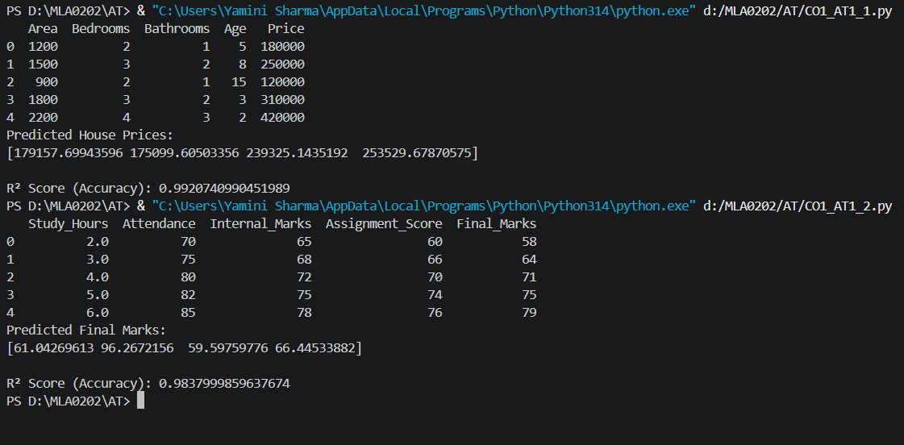
This is the output of both the programs.
For house price prediction the R2 score was 0.99207.
For student performance prediction the R2 score was 0.98379.

